Chapter 5, Problem 8.

Obtain v_{o} for each of the op amp circuits in Fig. 5.47.

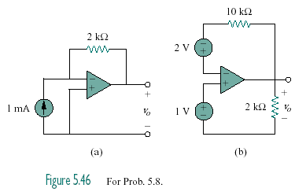

Figure 5.47
For Prob. 5.8.

